Telegram → Multi-Platform Video Publisher
N8N Automation Report
Telegram • YouTube • Facebook • Instagram • LitterBox • Google Sheets

Field | Details
Trigger | Telegram — New Message with Video
Platform | N8N
Integrations | Telegram, YouTube, Facebook Graph API, Instagram Graph API, LitterBox, Google Sheets
AI Model | None — fully rule-based
Output | Video published on YouTube, Facebook Page & Instagram Reels simultaneously

1 Workflow Overview
This workflow turns Telegram into a one-stop publishing hub for video content. When a video is sent to a Telegram bot along with a caption (used as the title/description), the workflow automatically downloads the video and distributes it to three platforms in parallel: YouTube (as a video upload), Facebook (as a page video post), and Instagram (as a Reel).

It also logs each published video's link and title to a Google Sheets tracker for record-keeping. Instagram's two-step async publishing process is handled with a status-polling loop that retries every 30 seconds until the media is ready to publish.

2 Workflow Diagram
The diagram below shows the full n8n automation pipeline — from Telegram trigger through parallel platform uploads to the Instagram status-polling loop and Google Sheets logging:

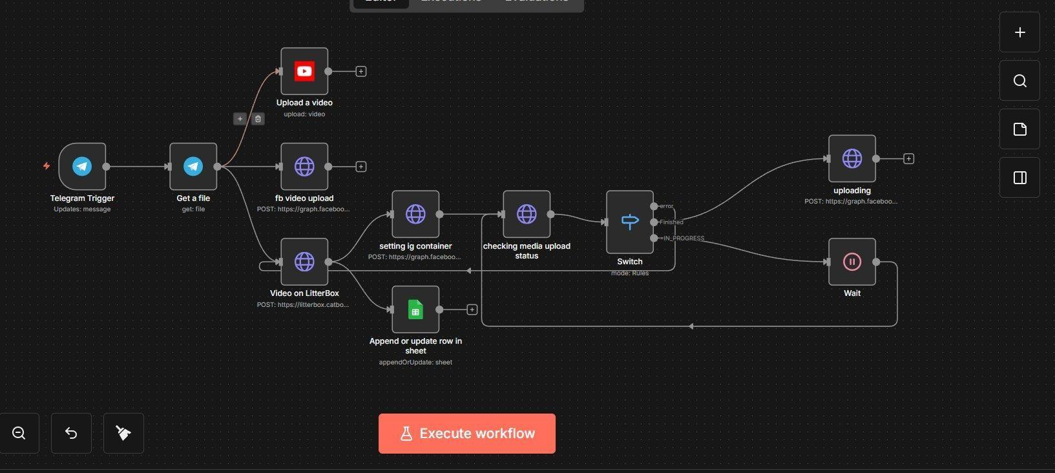
Main Workflow — Telegram → YouTube / Facebook / Instagram / Google Sheets

3 Automation Flow — Step by Step
# | Node / Action | Description
1 | Telegram Trigger | Fires when a video message is received by the bot (Updates: message).
2 | Get a File | Video file downloaded from Telegram as binary data (MP4).
3 | Upload a Video — YouTube | Video binary uploaded directly to YouTube with Telegram caption as title, region AE, category 26 (How-to & Style).
4 | FB Video Upload — Facebook | Video binary uploaded to the Facebook Page via Graph API multipart form upload, caption used as description.
5 | Video on LitterBox | Video uploaded to LitterBox (temporary public host, 1-hour TTL) to generate a public URL required by Instagram.
6 | Setting IG Container | LitterBox public URL used to create an Instagram Reel media container via the Instagram Graph API with caption attached.
6b | Append Row in Sheet | LitterBox URL and video title logged to Google Sheets simultaneously (append or update row).
7 | Checking Media Upload Status | Container status polled via Graph API. Switch node routes: ERROR → re-upload; FINISHED → publish; IN_PROGRESS → wait.
8 | Switch Node | Routes flow by media status code: ERROR branch restarts LitterBox upload; FINISHED proceeds to publish; IN_PROGRESS triggers wait.
9 | Wait (30s) | Pauses execution for 30 seconds while Instagram processes the media container, then loops back to recheck status.
10 | Uploading — Publish | Once container status is FINISHED, media published to Instagram using the media_publish endpoint.

4 Parallel Publishing Branches
After downloading the video from Telegram once, the workflow fans out to three simultaneous upload paths — eliminating redundant downloads and minimising total publish time:

YouTube Branch | Facebook Branch | Instagram Branch
• Direct binary upload  • Caption → Title  • Region: AE  • Category: 26 (How-to & Style)  • Instant publish | • Multipart form upload  • Graph API endpoint  • Caption → Description  • Posted to Facebook Page  • Instant publish | • LitterBox → public URL  • Create Reel container  • Poll status loop (30s)  • ERROR → self-heal  • Publish on FINISHED

5 Instagram Status-Polling Logic
Instagram media processing is asynchronous. After the Reel container is created, the workflow continuously checks the container's status_code via the Graph API. The Switch node routes execution based on the result:

Status Code | Switch Node Action
FINISHED | Container is ready — proceeds to publish on Instagram immediately
IN_PROGRESS | Container still processing — waits 30 seconds then loops back to recheck status
ERROR | Container failed — routes back to LitterBox re-upload and recreates the container (self-healing)

6 Challenges & How the Workflow Addresses Them

- Instagram does not accept direct binary video uploads:
→ Instagram's Graph API requires a publicly accessible URL for media container creation. LitterBox is used as a temporary file host to generate a short-lived public URL, bypassing the binary upload limitation entirely.
- Instagram media processing is asynchronous — publish cannot happen immediately:
→ After creating the media container, the workflow polls the container's status_code in a loop. A Switch node routes to a 30-second Wait node if the status is IN_PROGRESS, then loops back to recheck until the status becomes FINISHED before publishing.
- Instagram media container may fail during processing (ERROR state):
→ The Switch node has a dedicated ERROR branch that routes back to re-upload the video to LitterBox and recreate the container, making the flow self-healing without manual intervention.
- Three platforms require three different upload methods from the same source video:
→ After downloading the file once from Telegram, the Get a file node fans out to all three upload paths simultaneously — YouTube node, Facebook Graph API (multipart), and LitterBox — eliminating redundant downloads.
- No built-in record of published videos:
→ The Google Sheets node runs in parallel with the Instagram container step, logging the LitterBox URL and caption immediately after upload — ensuring a persistent record regardless of whether the Instagram publish succeeds.

7 Tools & Integrations
Tool / Service | Role in Workflow
Telegram Trigger + Bot | Receives video + caption and triggers the workflow
YouTube Node | Uploads video directly to YouTube channel
Facebook Graph API | Posts video to Facebook Page via multipart upload
LitterBox (catbox.moe) | Hosts video temporarily as a public URL for Instagram (1-hour TTL)
Instagram Graph API | Creates Reel container and publishes to Instagram
Switch Node | Routes Instagram flow by media status: ERROR / FINISHED / IN_PROGRESS
Wait Node (30s) | Pauses execution while Instagram processes the media container
Google Sheets | Logs published video URL and title as a tracker record

8 System Architecture Summary
TRIGGER SOURCE | N8N AUTOMATION | OUTPUT
• Telegram Bot Message  • Video + Caption | • File Download  • Parallel Upload (×3)  • LitterBox Hosting  • IG Container + Status Loop  • Switch Routing  • 30s Wait & Retry | • YouTube Video Published  • Facebook Page Post  • Instagram Reel Published  • Google Sheets Row Logged

